**DICOM anonymization**

**Installing DICOM-**

* download the source code from the [Downloads tab](http://code.google.com/p/pydicom/downloads/list) .(Second file in the Screenshot)
* at a command line, change to the directory with the setup.py file
* with admin privileges, run python setup.py install

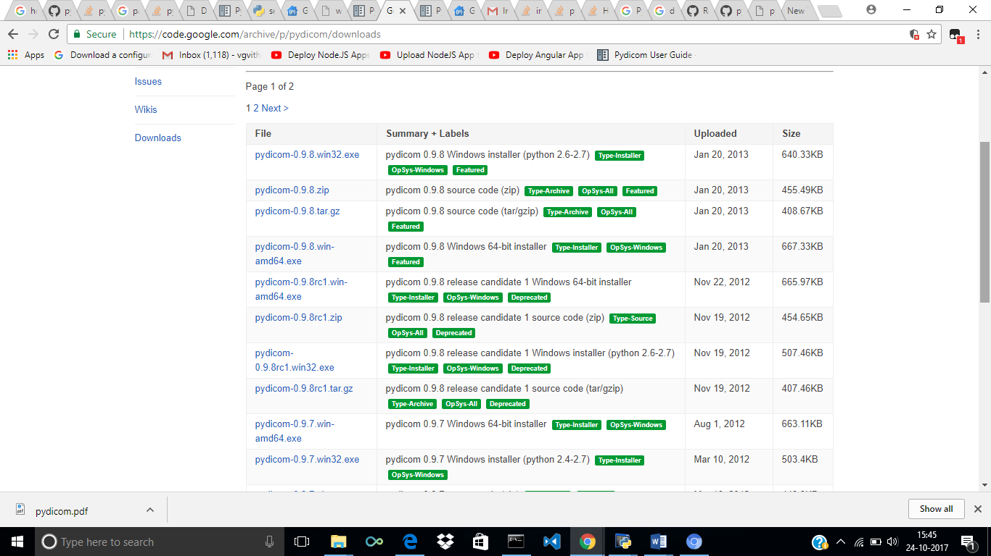

**DICOM anonymization**

**Step 1**

>>> import dicom

**Step 2**

>>> ds=dicom.read_file('C:/testfiles/MR_small.dcm','br') //Readng dcm file.

**Step 3-**

>>> ds.dir

//gives a list of whole data (showing some here)

(0008, 0201) Timezone Offset From UTC SH: '-0400'

(0008, 1010) Station Name SH: '000000000'

(0008, 1060) Name of Physician(s) Reading Study PN: '----'

(0008, 1070) Operators' Name PN: '----'

(0008, 1090) Manufacturer's Model Name LO: 'MRT50H1'

(0010, 0010) Patient's Name PN: 'CompressedSamples^MR1'

(0010, 0020) Patient ID LO: '4MR1'

(0010, 0030) Patient's Birth Date DA: ''

(0010, 0040) Patient's Sex CS: 'F'

(0010, 1020) Patient's Size DS: ''

(0010, 1030) Patient's Weight DS: '80.0000'

(0018, 0010) Contrast/Bolus Agent LO: ''

(0018, 0020) Scanning Sequence CS: 'SE'

(0018, 0021) Sequence Variant CS: 'NONE'

Now for example: -

To anonymize data Patient ID here in this example –

We note (0010,10020) corresponding to Patients ID-

**Step 4-**

>>>print(ds[0x10,0x20].value) //gives Patient ID-

4MR1

**Step 5**

>>> ds[0x10,0x20].value="00ID" //making patient ID anonymize

**Step 6**

>>> ds.save_as("C:/users/hp/Modifieddata.dcm"); //Saving the new file after making patient ID anonymize

**Step 7**

>>> print(ds[0x10,0x20].value)// gives anonymized patient ID

00ID

**Step 8**

>>>ds.dir

0008, 1060) Name of Physician(s) Reading Study PN: '----'

(0008, 1070) Operators' Name PN: '----'

(0008, 1090) Manufacturer's Model Name LO: 'MRT50H1'

(0010, 0010) Patient's Name PN: 'CompressedSamples^MR1'

(0010, 0020) Patient ID LO: '00ID'

(0010, 0030) Patient's Birth Date DA: ''

(0010, 0040) Patient's Sex CS: 'F'

(0010, 1020) Patient's Size DS: ''

(0010, 1030) Patient's Weight DS: '80.0000'

(0018, 0010) Contrast/Bolus Agent LO: ''

(0018, 0020) Scanning Sequence CS: 'SE'

(0018, 0021) Sequence Variant CS: 'NONE'

(0018, 0022) Scan Options CS: ''

(0018, 0023) MR Acquisition Type CS: '3D'

(0018, 0050) Slice Thickness DS: '0.8000'

***NOTE- The highlighted portion shows anonymization of Patient ID in this case.***

Reference Link-

<http://jwitowski.com/dicom-anonymization-meta-data-processing/>

--------END---------